# AREL Social Plugin

Agenda

1. Overview 3

2. How to integrate the AREL-Social-Plugin 4

3. Add HTML-Buttons 5

4. Add Model3D Buttons 6

5. Costum Social Objects 7

## Overview

The AREL Social Plugin gives you the possibility to easily integrate social networks into your AREL Channel. Currently the following 4 social platforms are supported by the AREL Social Plugin:

* Twitter
* Facebook
* Google Plus
* YouTube

In each case the AREL Social Plugin routes the user to the according login page of the platform or opens the Youtube video in the junaio webview.

**Options:**

In case of Twitter you have the option to declare a default tweet message. This message then is automatically inserted into the message box of the twitter page.

If you choose Facebook or Google Plus you can declare the URL that should be shared by the user via the social platform.

Choosing Youtube you can specify the VideoID of the Youtube-Video. Depending on the mobile OS the Youtube video will be opened appropriately.

**Known Issue:**

There is a problem with the Google Plus Feature on some Android devices. The URL to Google Plus uses the HTTPS protocol. Normally this is supported by junaio, but Google Plus doesn’t return a valid security certificate. Some Android devices can’t handle this issue and abort the loading of the Google Plus website.

## How to integrate the AREL-Social-Plugin

The AREL-Social-Plugin uses the junaio AREL JavaScript Plugin interface.

Before you can use it you have to carry out the following three steps:

**STEP 1:** Copy the “arel_plugin_social” folder into the “js” folder of your AREL project.

**STEP 2:** Reference the file in your HTML overlay (e.g. html/arel/index.php). Make sure you include “arel_plugin_socialarel_plugin_social_v1.js” before your AREL JS logice file (e.g. socialLogic.js).

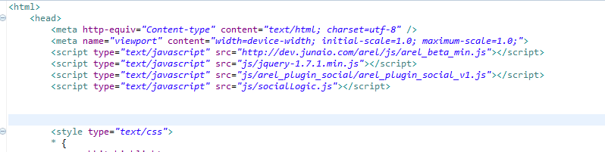

**STEP 3:** Create an instance of arel.Plugin.Social in your AREL JS logic file (e.g. html/arel/js/socialLogic.js)

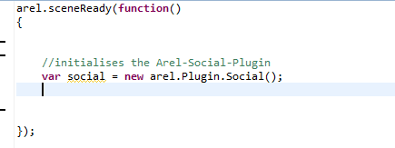

## Add HTML-Buttons

To add a social-HTML button to the junaio-html overlay you just need one line of code. To include the platform specific buttons use one of the following four functions:

addTweetButton( *optionalParam* );

addFacebookShareButton( *optionalParam* );

addGooglePlusShareButton( *optionalParam* );

addYouTubeButton( *optionalParam* );

**Here you can see a small example:**

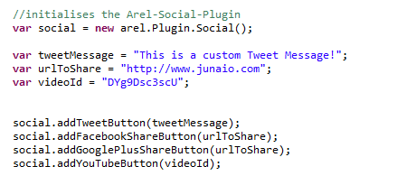

Depending on the platform the optionalParam should contain the following information.

Twitter: A custom text message no longer than 140 signs.

Facebook: A valid URL starting with “http://”

Google -Plus: A valid URL starting with “http://”

Youtube: The Youtube id of the desired youtube video.

If you use one of these functions without passing the optionalParam a default value will be used:

**Default values:**

Twitter: Check out this Channel “URL of the channel" on junaio!

Facebook: URL of the channel

Google -Plus: URL of the channel

Youtube: vEM_iW9WRUQ

A social-HTML button will always be located in the bottom right corner of the screen. If you add more than one social-HTML button, the next button will be located left beside the previous buttons.

**This is the result of the code snippet above:**

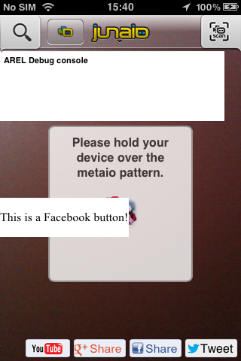

## Add Model3D Buttons

Beside the social-HTML buttons you also have the possibility to include a social-3D button to your channel. Please keep in mind that this will only work with a junaio-glue channel. Use one of the following four functions to include a 3D button to your channel:

createGlueTwitterModel3D( *objectID, coordinateSystemId, optionalParam* );

createGlueFacebookModel3D( *objectID, coordinateSystemId, optionalParam* );

createGlueGooglePlusModel3D( *objectID, coordinateSystemId, optionalParam* );

createGlueYouTubeModel3D( *objectID, coordinateSystemId, optionalParam* );

**Here is again a small example:**

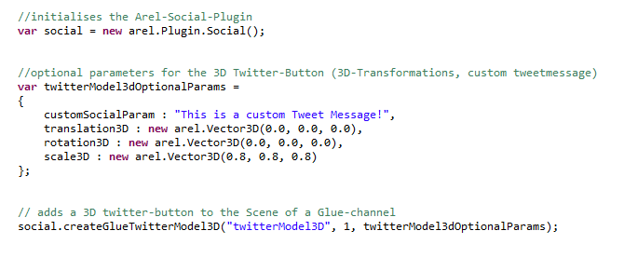

To create a social-3D button you have to pass at least two parameters to one of the four functions. The first parameter represents the ID of the arel.Object.Model3D which will be created automatically. You can choose it on your own. The second parameter is the coordinateSystemID of the pattern you choose to display the 3D button. The third parameter is optional. It’s a small object with four members. It’s not affordable to specify all of them but please be aware of the member variable names. **Don’t change them.** The first member represents the customTweetMessage, shareURL or VideoID depending on the chosen platform. The other three members could be used to place the 3D button in the 3D-scene of the rendering-view.

**Result of the code snippet above:**

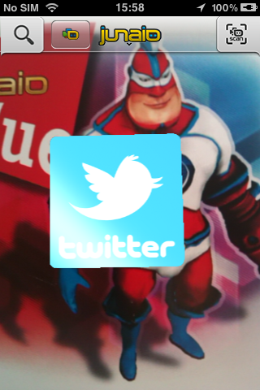

## Costum Social Objects

With the AREL Social Plugin you also have the possibility to add social functionality to an existing arel.Object or HTML-Element. To achieve this, use the following four functions:

addTwitterFunctionality( *object, optionalParam* );

addFacebookFunctionality( *object, optionalParam* );

addGooglePlusFunctionality( *object, optionalParam* );

addYoutubeFunctionality( *object, optionalParam* );

**arel.Object example:**

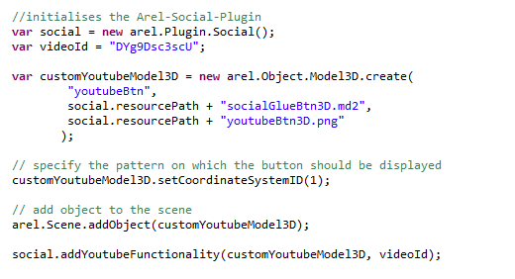

The main focus lies on the last line of the code snippet. The first parameter is mandatory. Pass a valid arel.Object to the function and it will become a social-Object. Whenever you touch the object on the screen of your smart-device the chosen social-Functionality will be triggered. The second parameter is again optional and depends on the chosen platform.

**HTML-element example:**

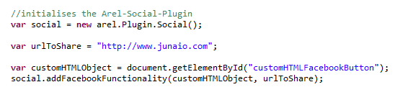

In this example we passed a HTML-element instead of the arel.Object to the function. Whenever the user touches the custom HTML-element the social-Functionality will be triggered. The second parameter is again optional. If you don’t specify it a default value will be used instead.